Diode 1N4001
CP008
Image:
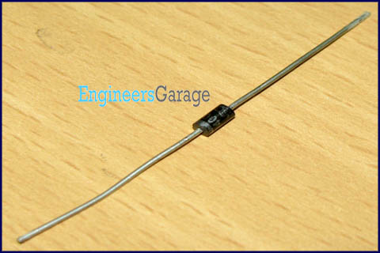
DataSheet:
1N4001.pdf
1N4001 is a member of 1N400x diodes. Diode is a rectifying device which conducts only from anode to cathode. Diode behaves open circuited for the current flow from cathode to anode. 1N4001 is a 1A diode with low forward voltage drop and high surge current capability. It comprises of diffused PN junction and has low reverse leakage current of 5µA. Its DC blocking voltage is 50V.
The cathode (n) is identified by a bar on diode case. The other terminal is the anode (p).

Pin Diagram:
